**Holiday Fundraiser**

**The Friends of the Pittsburg Library are hosting a fundraiser.**

**They are selling tickets for a drawing to be held on December 18, 2015 for a 7” Kindle Fire.**

**Tickets are $2.00 Each.**

**This would make a Great Christmas gift!**

**Product Details**

* 7" HD touchscreen with advanced polarizing filter, and anti-glare technology (1280 x 800)
* 8GB of internal storage

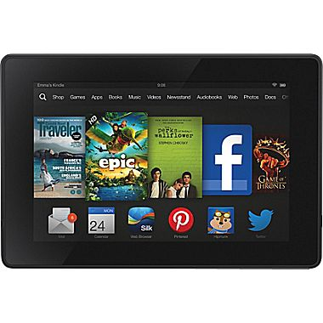

**For tickets, please contact the Pittsburg-Camp County Public Library at 613 Quitman St., Pittsburg, TX 75686, (903)856-3302. Sponsored by The FRIENDS of the Pittsburg-Camp County Public Library.**